**Maglev Train**

ANTU ASIF IKBAL,ID:17-34554-2, Section: I, Dept: CSE,

University: American International University-Bangladesh

HASAN MD. KAMRUL,ID :17-33826-1, Section:I, Dept:CSE,

University :American International University-Bangladesh

CHANDRIKA MALIHA TABASSUM,ID : 16-33062-3, Section:I , Dept:CSE,

University : American InternationalUniversity-Bangladesh

**Abstract:**

In this paper technology, electro Magnetic suspension, development of Magnetic Levitation trains is included. Maglev trains are under implementation phase in various countries for its high-speed velocity. A maglev train basically runs on wheel before levitated and when there is enough electromagnetic force to levitate the train it retracts those wheels. Magnetic trains have gained 600km/sec and this speed is not the limit also, it gains a levitation around 3.6 centimeters. In near future maglev high speed rails will add a whole new contrast in fast travelling.

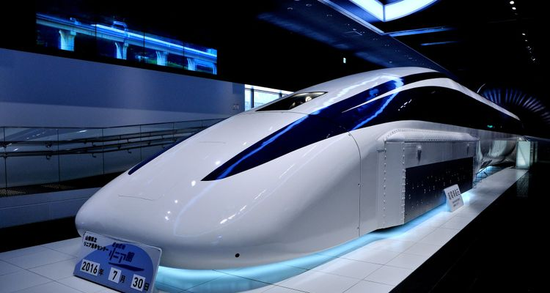

**Introduction:**

Maglev stands for Magnetic levitation which was invented by James Powell and Gordon Danby around 1960s.First commercial maglev train was introduced in 2004 in Shanghai. The basic concept of maglev is a train car with magnets on each corner of bogey. There are superconducting magnets in the train and when these magnets temperature is less than 450-degree Faten Heit these magnets can generate 10-time stronger electromagnets which is sufficient to propel and fly a train. When it comes to levitation and controlling the train there comes loop for us. Basically, there are 3 types of loops in maglev. Among them one creates a field that helps the train to levitate. Another loop makes the train horizontally stable. And the third loop is mainly propulsion system for the train which is run by alternating current power. AS the train floats above the ground, this train gives a smooth trip than other trains. Also, maglev trains only run through the powered guideway, so collision chance is 0 percent.

**Motivation:**

But maglev train are fastest train mainly. With the exponential growth of the relatively old concept of maglev, the installation of the system and managing this are still very complex to deal with. In this project, I know about maglev train that manage

multiple end points like time, it has high- speed, like it reaches 600 kilometers per hour. Nowadays public form China, Japan, south Korea are using maglev train more and more. On one hand, it provides comfort, reached the place in time and used here high safety technology and make easier way of living. On the other hand, maglev train have disadvantages too. It has extremely high-speed and uses less energy than normal train. It is also very expensive because of more perfect technology used in it. It is not only increase comfort, but also helps people’s lifestyle, like people can utilize their time properly which is really time-consuming fact. Previous research on this field did not clear the real time work and did not focus on this research cost because cost is important for every research. Our research will decrease the cost form the other research based one on this field.

**Objective:**

From this research we can learn about maglev, so that we can know the future of maglev. Through this, some of questions may come to mind that-

1.How magnets create something that move this train?

2.How much high-speed maglev train reach the pickup point?

3.How magnetism works on maglev train?

4.How maglev runs without touching ground or why don’t it have wheels?

5.What are the main facts that magnetic forces mainly work maglev train?

6.Is maglev train eco-friendly or did it impact on any kind of pollution?

**Maglev Working Techniques:**

In this research, we know current description of progress that maglev how works, like electromagnetic suspension that is called (EMS) and electrodynamic suspension (EDS). In this thesis, mainly discussed about practically working process that impact in daily life. In this concept the train mainly depends on magnetic suspension some collected data usual magnet refuse to accept it from the track along something moves more that attract it.

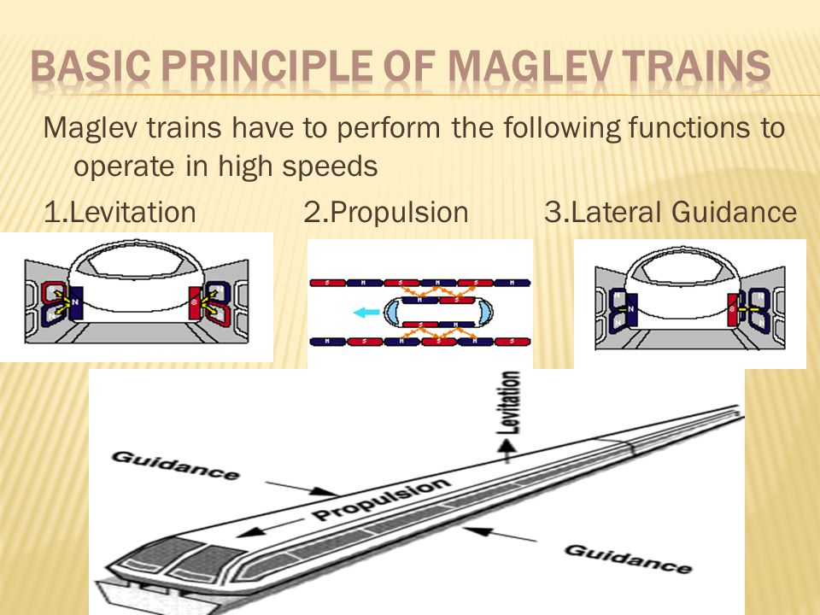

**Maglev EDS and EMS Techniques:**

Two types of Maglev trains are commonly illustrated in based on the Levitation technology used. EDS, which employs repulsive forces, is the more intuitive of the two designs. EMS is intrinsically unstable, in contrast to an EDS system.

* **EDS System:**

The maglev vehicles in most EDS ideas are powered by superconducting magnets (SCMs) that interact with a conducting guide-way. The repelling force grows as the distance between the vehicle and the guide-way diminishes, making an EDS system intrinsically stable. This stability allows the EDS vehicle to carry more weight without losing much levitation, and it also prevents any potentially disastrous rapid levitation losses.

* **EMS System:**

Repulsion and attraction EMS systems exist. The repulsive system that can be achieved using materials with permeability (r) less than unity (diamagnetic material) and superconductors with (r = 0). With a low damping ratio, these systems are naturally stable. Although the attraction type has the benefit of providing attraction force at zero speed, it is inherently unstable. The majority of the maglev vehicle rides above the rails in EMS designs, but a piece of it wraps around the guide-way on either side. The current in these electromagnets is controlled by a set of sensors and feedback circuitry, which keeps the spacing between the rails and the vehicle as constant as possible.

### **Propulsion:**

To propel the vehicle body, maglev systems require a contactless propulsion system. Linear motors are the best option for meeting this requirement because they generate thrust without requiring any mechanical conversion. Unlike rotary motors, linear motor thrust is independent of rail-wheel adhesion. As a result, these motors must generate both propulsion and braking forces for maglev systems. Such applications frequently employ linear DC and linear AC motors. Asynchronous or synchronous linear AC motors are both available. The two most common asynchronous motors are linear induction and linear switching reluctance motors.

**COMPARISION WITH CONVECTIONAL TRAINS:**

At lower speeds, conventional railways are likely to be more efficient. Maglev trains, on the other hand, encounter no rolling resistance because there is no physical contact between the track and the vehicle, leaving only air resistance and electromagnetic drag, which could improve power efficiency. Rubber tires are used at low speeds in some systems, such as the Central Japan Railway Company SC Maglev. Electromagnet weight appears to be a significant design challenge in many EMS and EDS designs. To levitate a maglev vehicle, a strong magnetic field is needed. This equates to between 1 and 2 kilowatts per ton for the Transrapid (German maglev). The use of superconductor magnets to lower the energy consumption of the electromagnets and the expense of sustaining the field is another path for levitation. At speeds above 100 mph, the TRS expends the majority of its energy on propulsion and overcoming air resistance friction. Maglev trains would be heavier, whereas convectional trains would be lighter. Maglev trains create less noise than conventional trains at equal speeds since their main source of noise is displaced air.

* **CONTROL SYSTEMS:**

For both high and low speed maglev systems, no signaling systems exist. Since all of these systems are computer-controlled, there is no need for this. Furthermore, no human operator could react quickly enough to halt or stop these devices at their exceedingly high speeds. This is also why these systems necessitate separate rights of way and are typically suggested to be elevated several meters above ground level. At all times, two maglev system microwave towers are in touch with an EMS vehicle providing two-way communication between the vehicle and the main operations computer at the central command center. Train whistles and horns are unnecessary as well.

* **FLEXIBILITY & RELIABILITY:**

Commercial aviation routes, on the other hand, are not theoretically flexible. Maglev trains are designed to compete with flights of fewer than 800 kilometers in terms of travel time. Furthermore, whereas maglevs may serve multiple cities in between such routes and remain on schedule in all-weather situations, airlines cannot match such dependability or performance. Maglev tickets are less sensitive to the significant price volatility produced by oil markets since maglev cars are powered by electricity and do not transport petroleum. Because maglevs are intended not to collide with other maglevs or leave their guideways, maglev travel offers a considerable safety advantage over air travel. During takeoff and landing, there is a substantial risk of an accident involving aircraft fuel. Although maglev trains go slower than planes in real-world settings, they save time because they have fewer obstacles to overcome than planes. People must spend time at airports for check-in, security, and boarding, among other things, when traveling by air. The aircraft consumes time in air travel for taxing, waiting in line for take-off, and landing, which is insignificant in maglev.

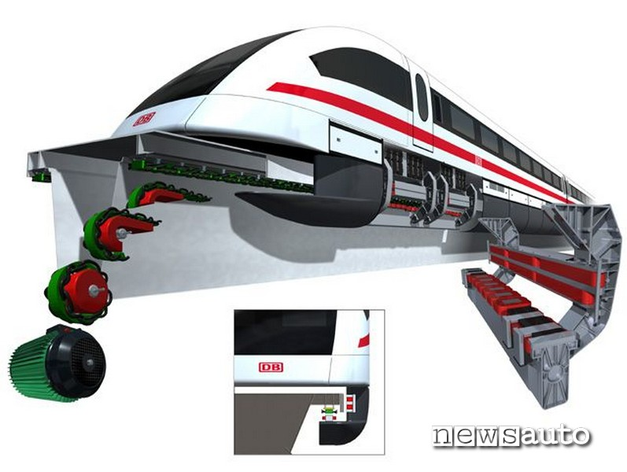

**Conclusion:**

Maglev technology has arisen as a sustainable, faster, and cleaner option in light of expanding transportation, energy requirements, and worldwide environmental effect. This study provides a bird's-eye view of maglev technology, with a focus on electrical system components. Each technology for levitation, steering, and propulsion has its own capabilities and limits in terms of cost, working air gap, efficiency, performance, complexity, control, safety, and comfort. Magnetic-repulsive force-based levitation and steering are the most suitable of these methods for speeds over 350 km/h. The world's fastest trains are currently maglev systems based on this technology. However, while the use of superconductors in maglev systems greatly improves speed and drive performance, the consequent cost limits and ride discomfort have prompted researchers to investigate the use of permanent magnets and hybrid magnets in these applications.

**Paper writing contribution**

|  |  |  |
| --- | --- | --- |
| Student id & name | Section  No | Section Title |
| Antu Asif Ikbal(17-34554-2) | I | Abstract,Introduction,  COMPARISION WITH CONVECTIONAL TRAINS |
| Hasan,Md. Kamrul(17-33826-1) | E | Maglev EDS and EMS Techniques, Propulsion, Conclusion |
| Maliha Tabassum Chandrika  ,( 16-33062-3) | I | Motivation, Objective, Maglev Working techniques |

Table 2. Section(s) Written in the paper by the group member

|  |  |  |
| --- | --- | --- |
| Student id & NAME | Paper No frm  Ref | Paper Title |
| Antu Asif Ikbal(17-34554-2) |  | [*https://www.researchgate.net/publication/305481523_Research_review_on_magnetic_levitation_trains*](https://www.researchgate.net/publication/305481523_Research_review_on_magnetic_levitation_trains)  [*https://link.springer.com/article/10.1007/s40864-019-0104-1*](https://link.springer.com/article/10.1007/s40864-019-0104-1)*,*  *https://journals.sagepub.com/doi/abs/10.1177/0959651817750520* |
| Hasan,Md. Kamrul(17-33826-1) |  | [*https://www.sciencedirect.com/science/article/abs/pii/B9780444821393501282*](https://www.sciencedirect.com/science/article/abs/pii/B9780444821393501282)*,*  [*https://www.tandfonline.com/doi/full/10.1080/15568318.2020.1789780*](https://www.tandfonline.com/doi/full/10.1080/15568318.2020.1789780)*,*  *https://scholar.google.com/scholar_lookup?title=Maglev+Train&author=Wu,+X.M.&publication_year=2003* |
| Maliha Tabassum Chandrika  ,( 16-33062-3) |  | [*https://www.maglev.net/maglev-benefits*](https://www.maglev.net/maglev-benefits)*,*  [*https://www.globaltimes.cn/page/202107/1228998.shtml*](https://www.globaltimes.cn/page/202107/1228998.shtml)*,*  [*https://science.howstuffworks.com/transport/engines-equipment/maglev-train.htm*](https://science.howstuffworks.com/transport/engines-equipment/maglev-train.htm) |